Software Design Approaches - Top-Down

📖 Definition
# Source: AI Source: Provided by: [Data Path: Persons Table -> ID Column: 1, Name_En Column: Motasem Essam] -> From: [ChatGPT] on [1/23/2026]
The Top-Down Design Approach is a method where the system is designed by starting from the highest-level overview and gradually breaking it down into smaller, more detailed components or modules.
👉 In simple terms:
“Start with the big picture, then divide it into smaller parts.”

⚙️ How It Works
# Source: AI Source: Provided by: [Data Path: Persons Table -> ID Column: 1, Name_En Column: Motasem Essam] -> From: [ChatGPT] on [1/23/2026]
- Identify the main system or problem
- Break it into major sub-systems
- Further divide each sub-system into smaller modules
- Continue until each module is simple enough to implement

🧩 Key Characteristics
# Source: AI Source: Provided by: [Data Path: Persons Table -> ID Column: 1, Name_En Column: Motasem Essam] -> From: [ChatGPT] on [1/23/2026]
- Uses step-by-step refinement (decomposition)
- Focuses on overall system structure first
- Each level adds more detail
- Often represented using hierarchical diagrams

✅ Advantages
# Source: AI Source: Provided by: [Data Path: Persons Table -> ID Column: 1, Name_En Column: Motasem Essam] -> From: [ChatGPT] on [1/23/2026]
- Clear structure: Easy to understand system architecture
- Better planning: Helps define system requirements early
- Improved organization: Logical breakdown of tasks
- Easier management: Suitable for large projects

⚠️ Disadvantages
# Source: AI Source: Provided by: [Data Path: Persons Table -> ID Column: 1, Name_En Column: Motasem Essam] -> From: [ChatGPT] on [1/23/2026]
- Delayed implementation: Coding starts later
- May overlook low-level details early
- Less flexibility if requirements change
- Integration issues may appear later

🎯 Use Cases
# Source: AI Source: Provided by: [Data Path: Persons Table -> ID Column: 1, Name_En Column: Motasem Essam] -> From: [ChatGPT] on [1/23/2026]
- Large systems with well-defined requirements
- Enterprise applications
- Systems requiring strong architectural planning

🛠️ Simple Example
# Source: AI Source: Provided by: [Data Path: Persons Table -> ID Column: 1, Name_En Column: Motasem Essam] -> From: [ChatGPT] on [1/23/2026]
Problem: Build an Online Shopping System
Top-Level System
- E-commerce System
Breakdown:
- User Management
- Product Catalog
- Shopping Cart
- Payment System
Further Breakdown (Example: Payment System)
- Payment Processing
- Invoice Generation
- Payment Validation
👉 Each module can then be developed separately.

🔄 Top-Down vs Bottom-Up (Quick Insight)
# Source: AI Source: Provided by: [Data Path: Persons Table -> ID Column: 1, Name_En Column: Motasem Essam] -> From: [ChatGPT] on [1/23/2026]
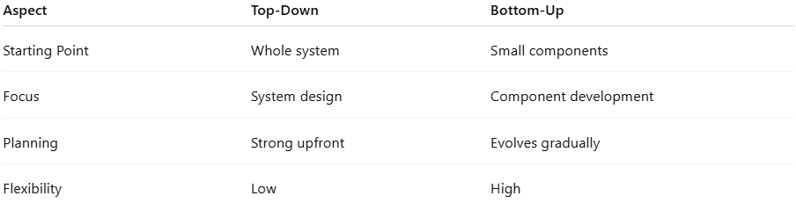
Aspect | Top-Down | Bottom-Up
Starting Point | Whole system | Small components
Focus | System design | Component development
Planning | Strong upfront | Evolves gradually
Flexibility | Low | High

📌 Summary
# Source: AI Source: Provided by: [Data Path: Persons Table -> ID Column: 1, Name_En Column: Motasem Essam] -> From: [ChatGPT] on [1/23/2026]
The Top-Down Design Approach focuses on breaking a system from a high-level overview into smaller, manageable modules. It is ideal for projects with clear requirements and structured planning, helping teams maintain clarity and organization throughout development. However, it may lack flexibility and delay implementation if changes occur later.

